DBSE Week 9

Created a Folder with name: frontend
Installed vite in the the folder along with npm axios and react router dom
Then created a sub folder called client with required components
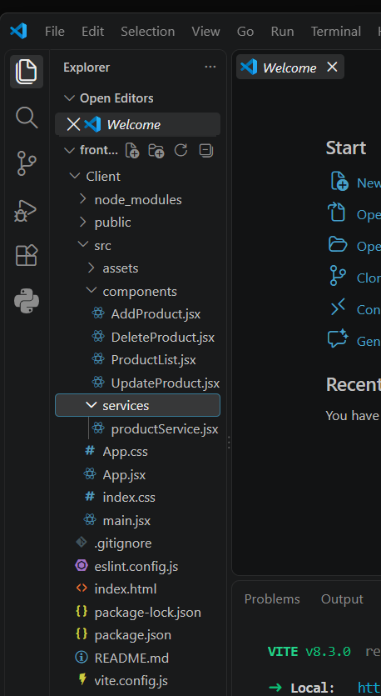
After adding respective codes into the files
Done the frontend part
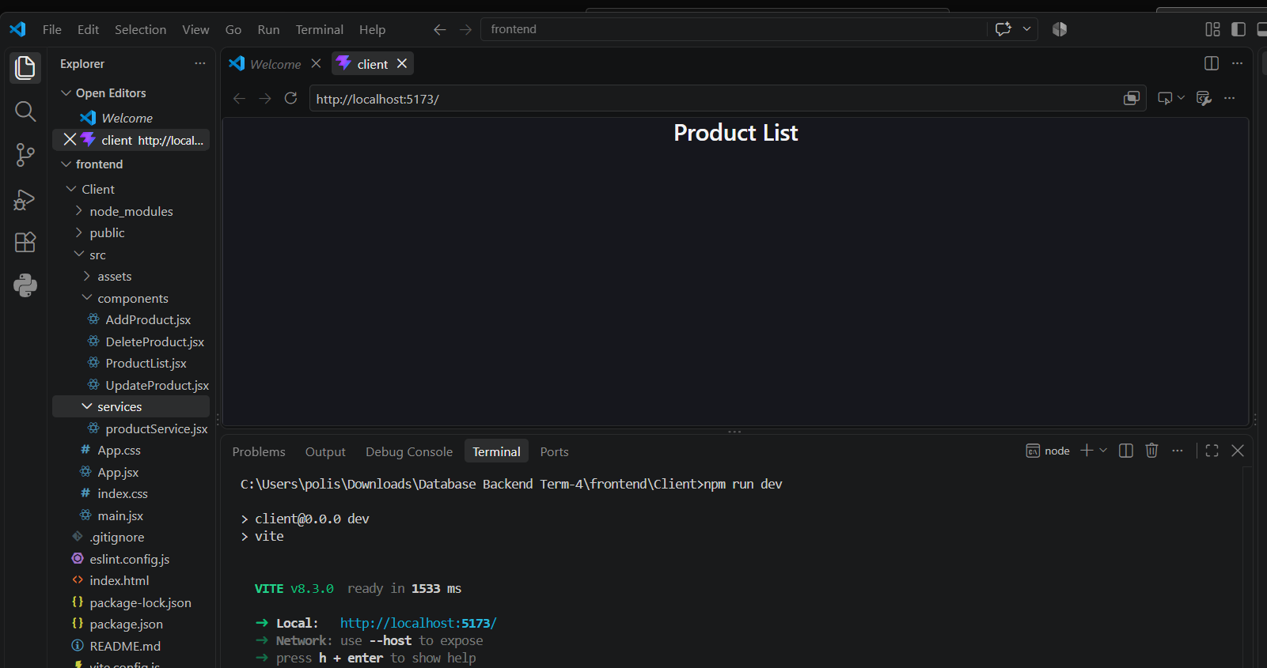
The below screenshot says that we can add products
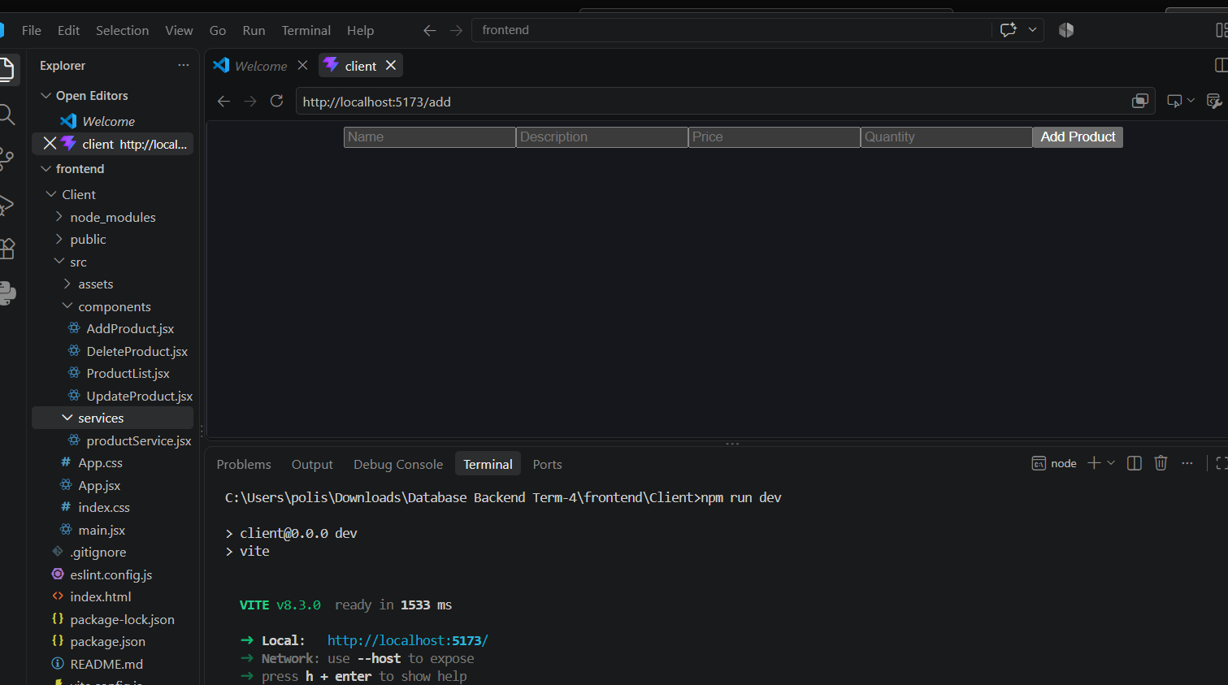
Then next Set up the backend by spring tool
1) Created a new Spring starter project called Product React

